
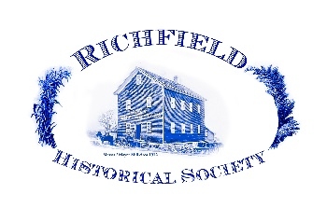
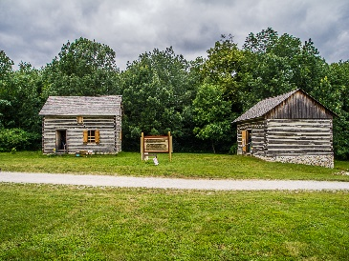
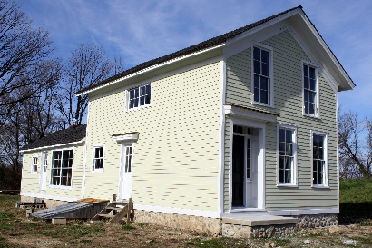
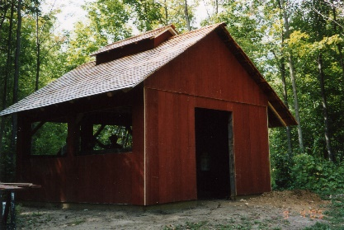
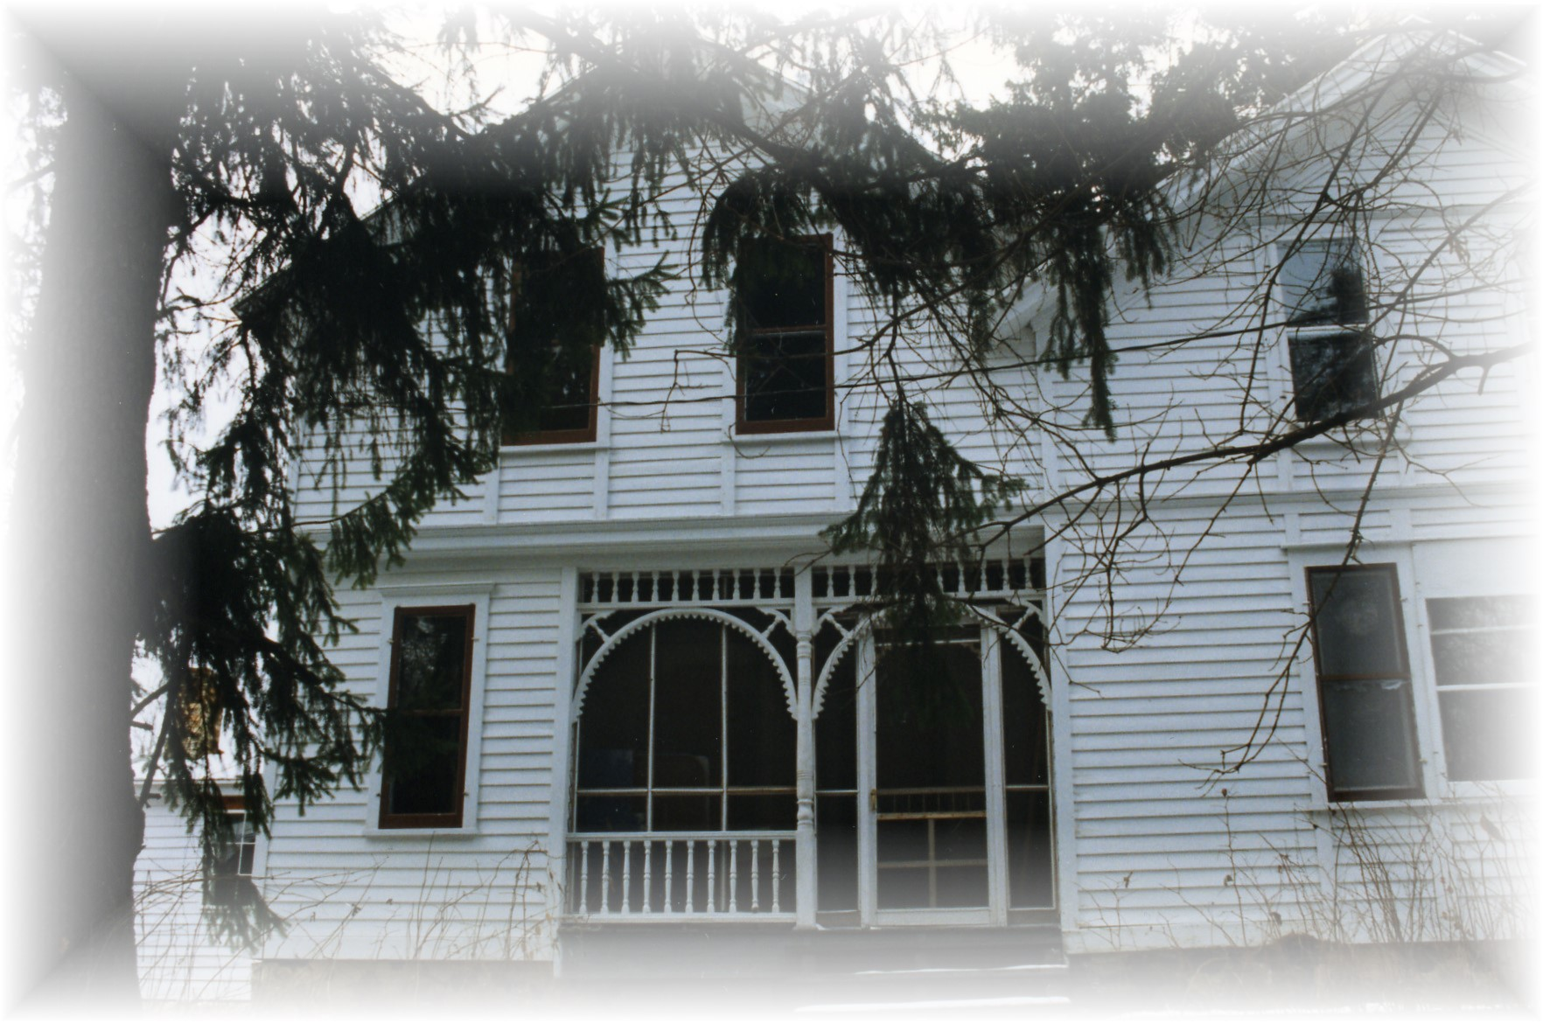



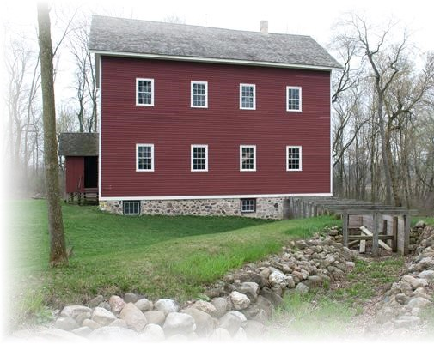
Richfie
Support Us
Friends???/Donors??
Community
Calendar
Messer/Mayer Mill
Contact Us
Donate
Friends/Donors
Messer/Mayer Mill
Contact Us
Community
Calendar

Home

Get Involved

Community Outreach

Richfield Historical Park

Richfield Remembers

Richfield Historical Society
Richfield, WI

Events

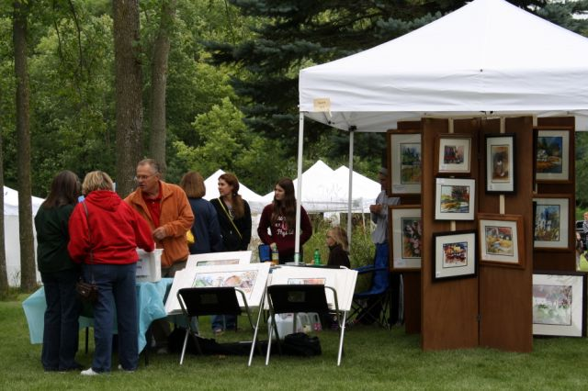

Happenings

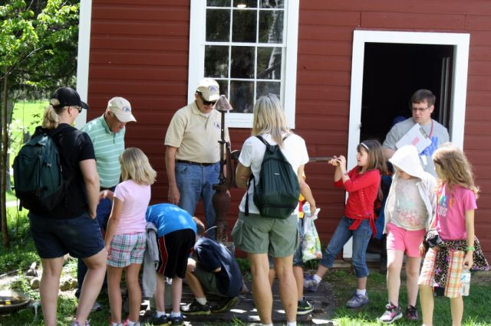

Pictures of activities going on at the park or with the society (ex.: Education Day, Working on the Lillicrapp House, etc.)
Have pictures along with a short description

List the rest of the events and programs for the year (link for each)
Site Search
Past Happenings (link)
Richfield Historical Society
Richfield, WI

Home

Get Involved

Community Outreach

Richfield Historical Park

Richfield Remembers

Events

Richfield Art at the Mill (link)
July 26, 2014
70 talented artists will be displaying their unique works along with several plein air artists……Read More

Photo Gallery

Pictures of activities going on at the park or with the society (ex.: Education Day, Working on the Lillicrapp House, etc.) Have pictures along with a short description…..Read More

Site Search
List the rest of the upcoming events and programs for the year (link for each)
Past Event #1 (link)
Past Event #2 (link)
Past Event #3 (link)

© 2014 Richfield Historical Society, PO Box 268, Richfield, WI 53076
Contact Us Get Involved Community Outreach Richfield Remembers Messer/Mayer Mill Donate Friends /Donors…Site Map

